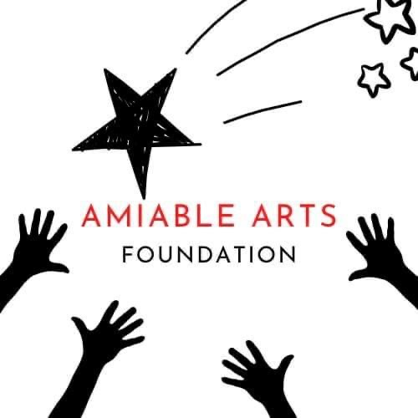
Amiable Arts Foundation is looking for an aspiring Public Relations Branding Expert.
This opportunity is open to recent college graduates or college seniors. This opportunity gives aspiring public relations, marketing, and creative professionals the chance to lead ideas on social media, website, branding, event, fundraising, etc. all while working side by side with the AAF CEO.
All fellowship candidates must provide resumés, writing and/or design samples and interview with AAF CEO and board prior to acceptance.

For more information or to apply, email: amia@amiaedwards.com.

